# Task 4 a

There was a slight issue with this question as per our discussion and all the necessary steps are performed and output is as per attached.

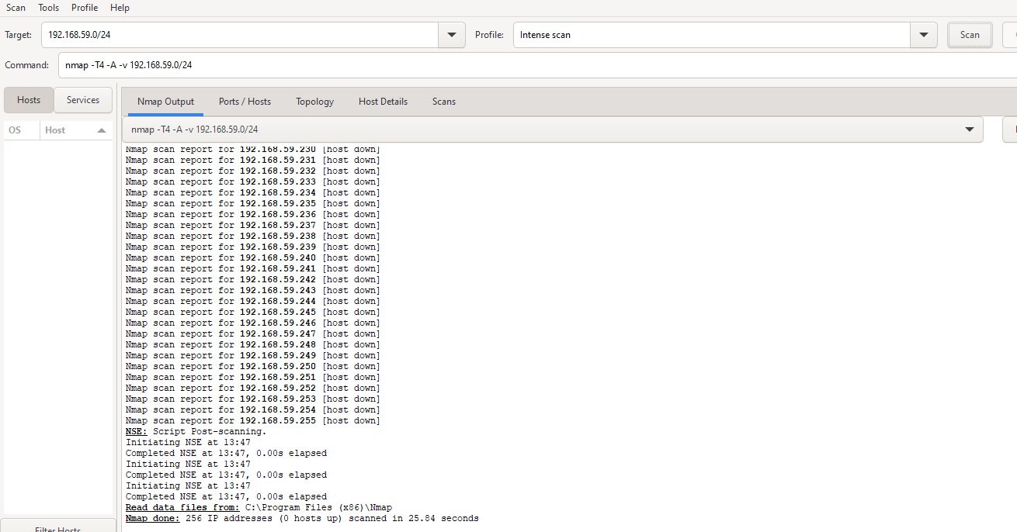

# Task 4 b

As no data was leaked as all security measures were already taken so the screenshot is as per attached below.

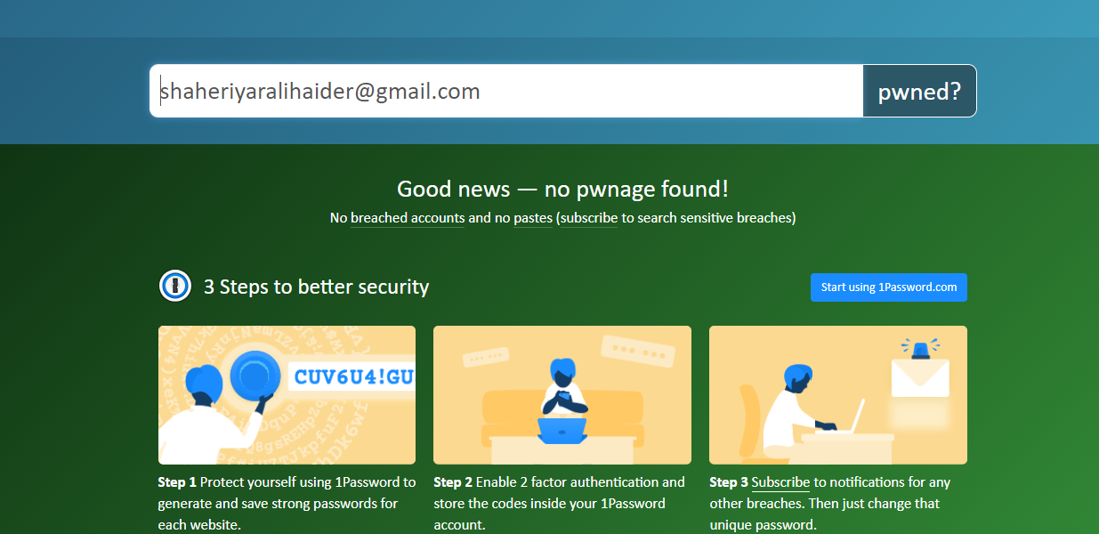

# Task 4 c

I tried to connect it through wazuh cloud but after following all the mentioned steps I was unable to turn the agent on the screenshots of the performed steps are as per mentioned below.(Discussed with the TA as well but we wasn’t been able to figure it out )

